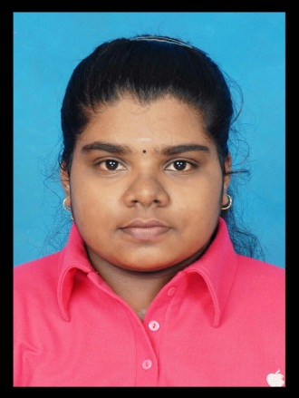**SIVASAKTHI D/O GANESAN**

No 507, Jalan Taman Pertama 12

Taman Pertama, Aulong,

34000, Taiping.

Perak Darul Ridzuan.

Contact No: 016-593362

Email Address: [siva12_12@yahoo.com](mailto:siva12_12@yahoo.com)

|  |
| --- |
| **PERSONAL PARTICULARS:** |

Age : 22 years

Nationality : Malaysian

Date of Birth : 12 December 1994

Gender : Female

I/C Number : 941212-08-6016

|  |
| --- |
| **EDUCATION BACKGROUND :** |

**Diploma in Finance and Banking (December 2012 –December 2015)**

Major: Finance and Banking

Institute: Ungku Omar Polytechnic (UOP), Ipoh

CGPA: 3.57 (SEM 6)

**Secondary Education**

School: Sekolah Menengah Kebangsaan Klian Pauh

Year: January 2007 – December 2011

Spm result: 3A 1B 2C 4E

|  |
| --- |
| **WORKING EXPERIENCE** |

**Industrial Training (Jun 2014- November 2014)**

**Majlis Perbandaran Taiping**

* Assisted rental department manager to organize the renting process.
* Assisted customers to sign rental contract.
* Assisted customer service manager to maintain good customer relations through providing necessary information required by clients.
* Assisted supervisor to site visit.

|  |
| --- |
| **EXTRA-CURICULLAR ACTIVITIES** |

**Ungku Omar Polytechnic**

* Participants of Novice Debate Competition 2013
* Vice chairman of English club at Ungku Omar Polytechnic

**Sekolah Menengah Kebangsaan Klian Pauh**

* School Prefects
* Reader Award Gold Level
* Participants of 1 Malaysia Essay Writing Competition 2011
* 100 % Attendance ( 2009 & 2011)
* Committee Member of Creative Arts Club
* Secretary of Recycle Club
* Attend U-Reka Design Workshop
* Best Reader Award (Tokoh Nilam) 2010

|  |
| --- |
| **SKILLS / STRENGTHS** |

* Strong communication (oral and written) and good management skills.
* Highly motivated, disciplined, energetic and enthusiastic.
* Proficient in Microsoft office (Word, Excel, Power Point).
* The ability to work within a demanding and dynamic team environment.

|  |
| --- |
| **OTHER INFORMATION** |

* Expected Salary: RM 1500 – RM 1800.
* Language (spoken/written): Tamil, Malay and English.

|  |
| --- |
| **REFERENCES** |

Majlis Perbandaran Taiping  
Jalan Taming Sari

34000 Taiping, Perak

05-8080777

Madam Faridah Bt Mohd Zin   
Academic Advisor

Commerce Department

Ungku Omar Polytechnic

Jalan Raja Musa Mahadi

31400, Ipoh

Perak Darul Ridzuan  
013-5087122